1. **Install Power BI Desktop and share the final screenshot of the report view page which appears when power desktop starts.**

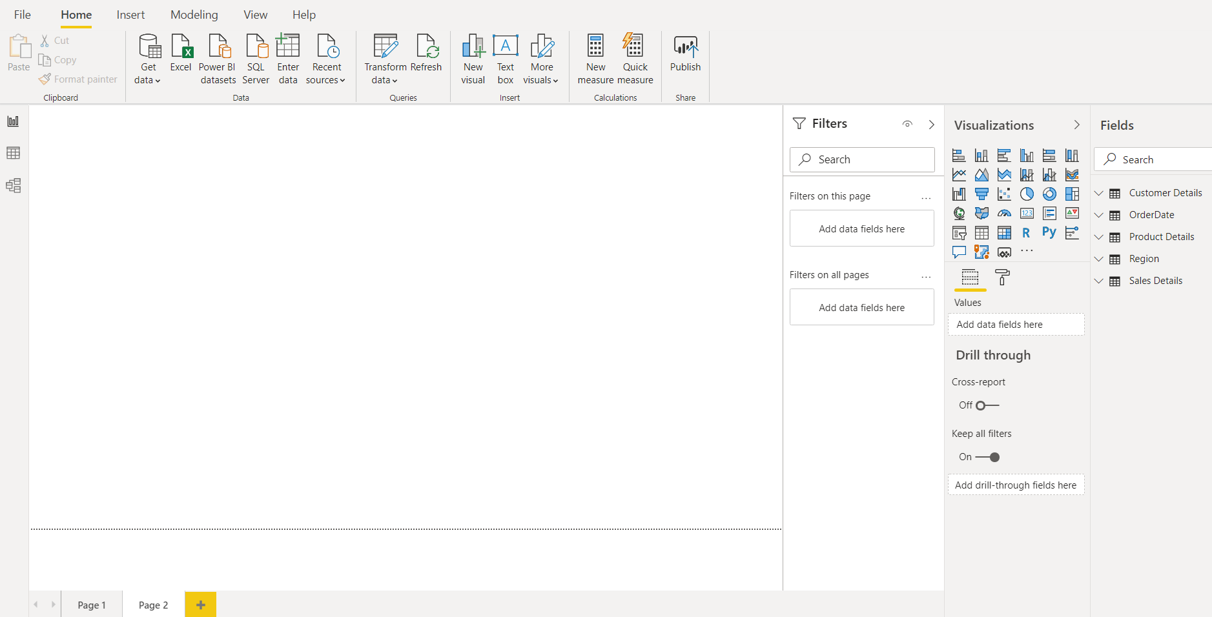

1. **Prepare a document and with the following screenshot**
2. **Report View**: A Power BI report is a multi-perspective view into a dataset, with visuals that represent different findings and insights from that dataset. A report can have a single visual or pages full of visuals.

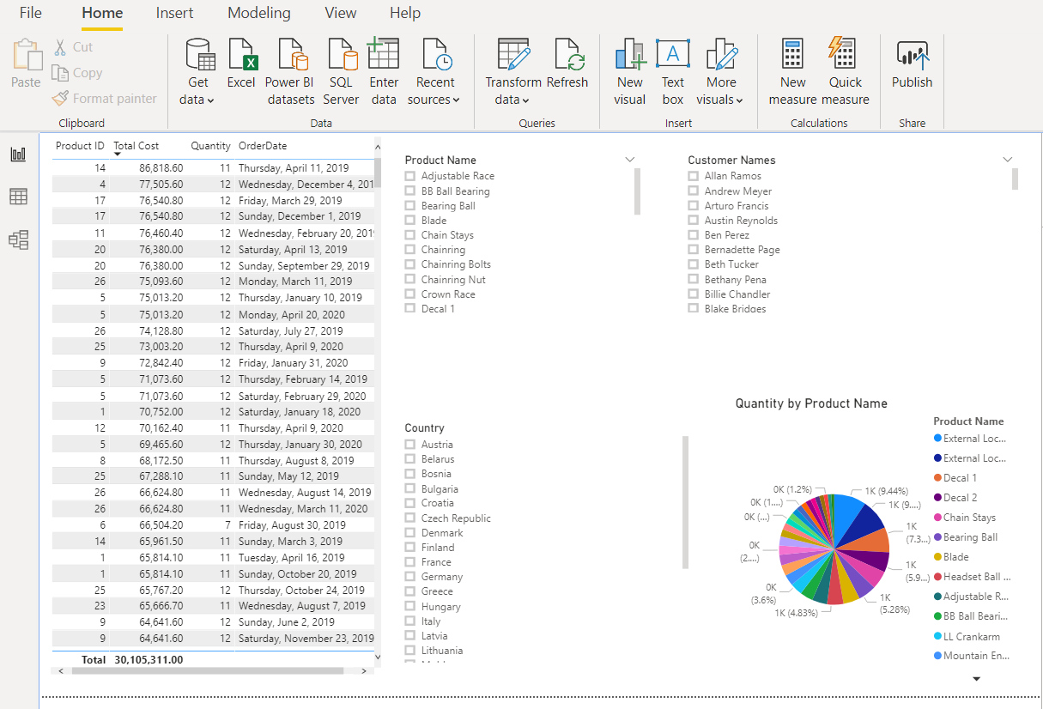

1. **Data View:** Data view helps you inspect, explore, and understand data in your Power BI Desktop model. It's different from how you view tables, columns, and data in Power Query Editor.

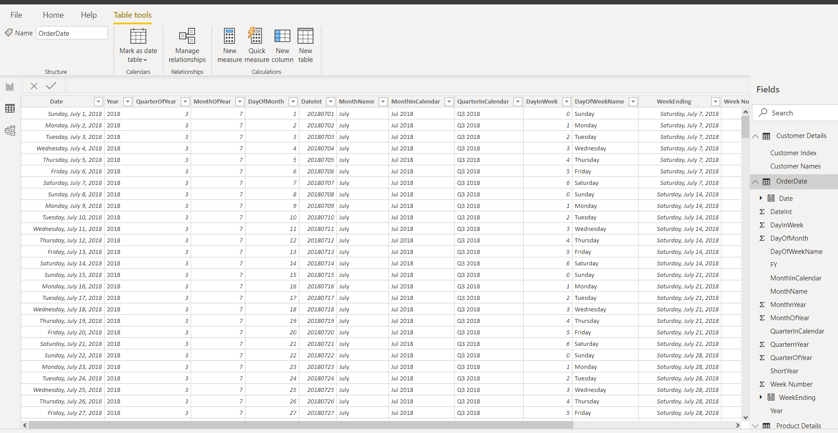

1. **Model View:** Model view shows all the tables, columns, and relationships in your model. This view can be especially helpful when your model has complex relationships between many tables.

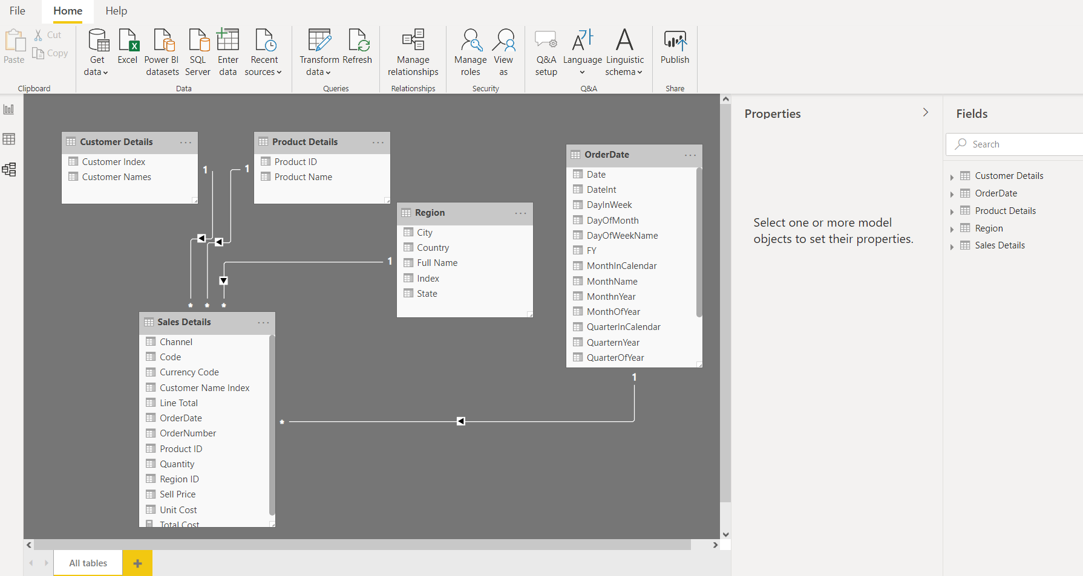

1. **Power Query Editor:** The Query Editor in Power BI is used to transform or edit data files before they are loaded into the Power BI. The Query Editor plays the role of an intermediate data container where you can modify data by selecting rows and columns, splitting rows and columns, pivoting and unpivoting columns, etc.

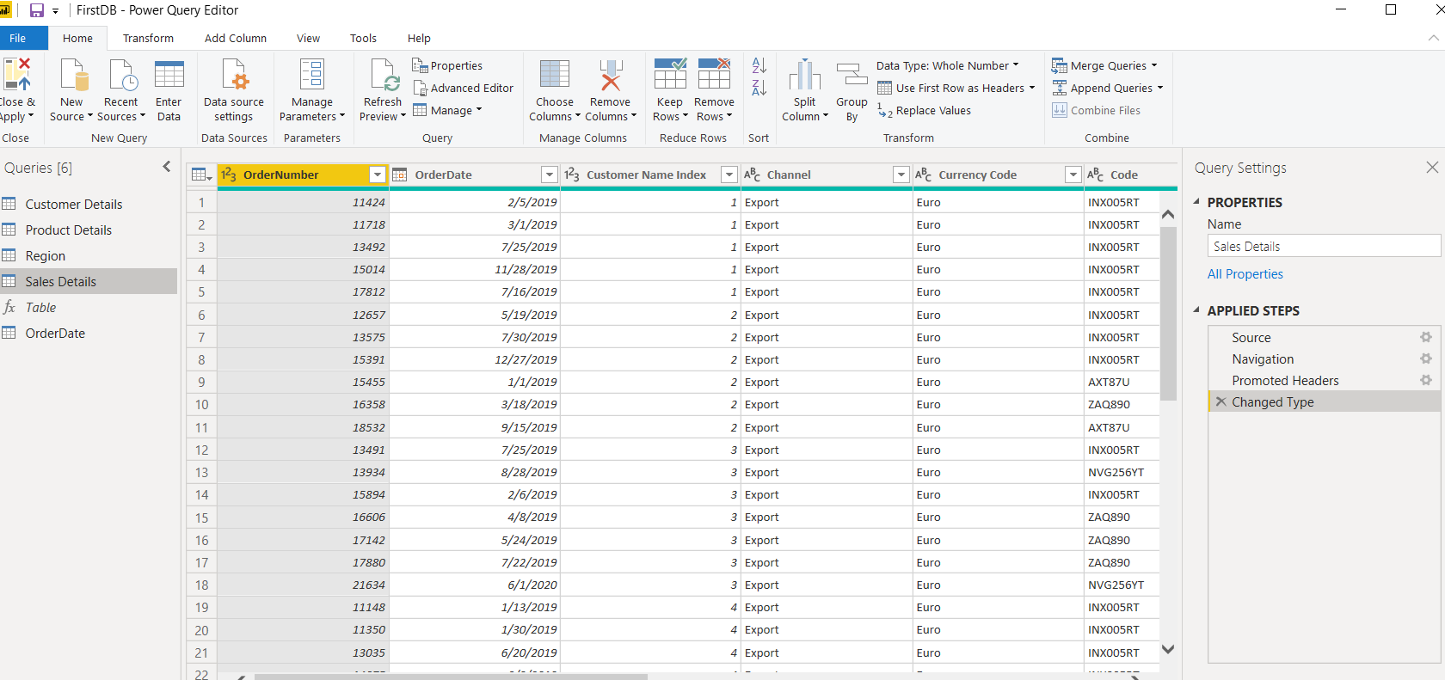

1. **Advance Editor:** In Power BI Desktop, the M code for each query can be accessed from the Advanced Editor window within the Power Query Editor. With the Power Query Editor open, select a query of interest from the list of queries on the left and click on the Advanced Editor icon from the Home tab to access the following window.

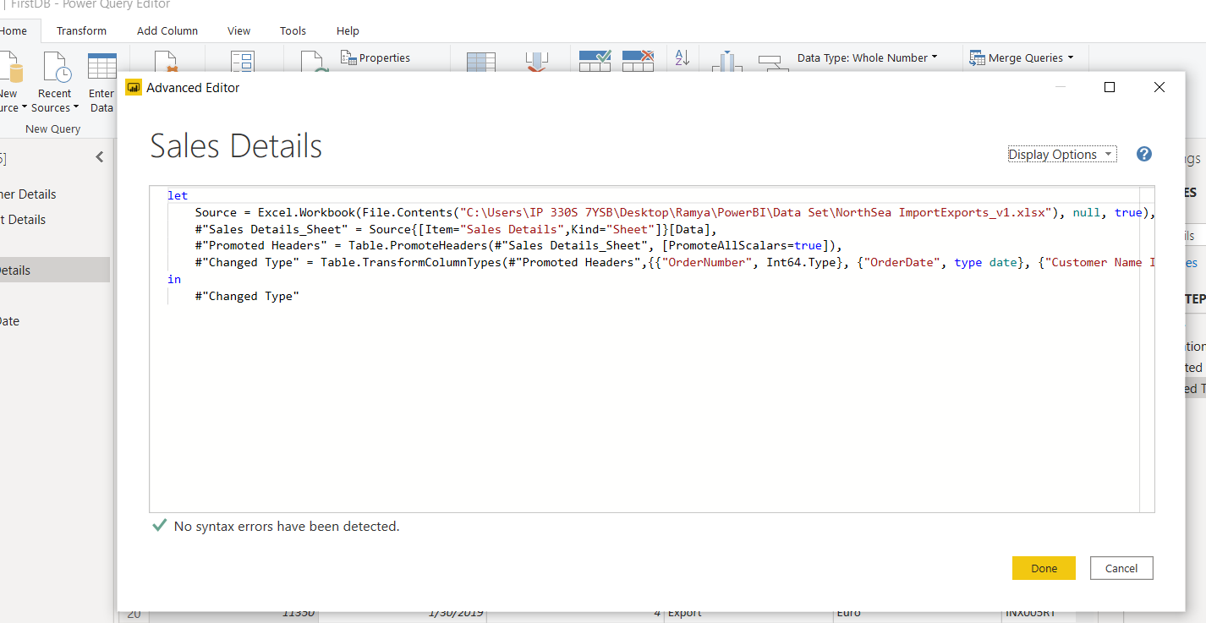

1. **Prepare a document with details of the following along with their price.**

**Power BI Desktop:**

Power BI Desktop is **the free version** of Power BI that can install on local computer as a program and acts as a companion desktop application to the full version of Power BI. If we need to consolidate our data sources, create our own reports and conduct our own analysis or test its capabilities, it’s the perfect version to start with for all skill levels - whether we’re non-IT and want to make our reports more interactive, or analysts seeking richer detail, it's one of the best business analytics tools to use.

**Power BI Pro:**

Power BI Pro is the full version of Power BI, complete with the ability to use Power BI for both building dashboards and reports and unlimited viewing, sharing and consumption of our created reports (and reports shared by others) - the latter not possible with Power BI Desktop.

Power BI Pro is licensed by individual user. For example, if an organization has 20 people that need to full capabilities of self-service BI to create dashboards and reports, they need 20 licenses of Power BI Pro, which gives these users full access to creation of reports and unlimited consumption (viewing) of any created content.

Power BI Pro pricing**starts at US$9.99 per month, per user.**

**Power BI Premium:**

Power BI Premium is the most expensive tier of Power BI currently available and very distinct from the other two versions available on the market. Power BI Premium differs from the free version and Power BI pro in its licensing model, which only suits a specific size and type of organization and business scenario. We can purchase Premium in a range of capacity sizes that offer different numbers of memory and virtual cores that can scale as your data analysis requirements change.

The Premium plan starts at **US$4,995 a month** per dedicated cloud compute and storage resource.